Perquisite to testing: There must be at least two subaccounts to advisory account. Subscription to market data must be available, and so subscription in account management is precondition to successful testing. (US Stocks)

Change mode to Classic TWS

API settings

Edit/Global Settings/ -> API/Settings

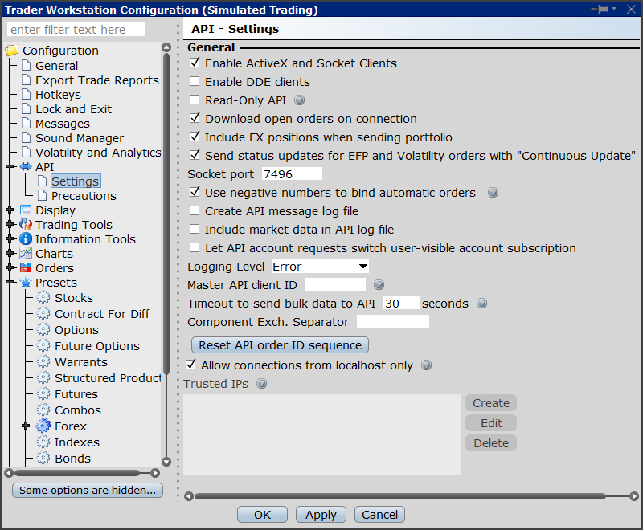

Test settings:

Project file : tests/test_settings.py

IB_TESTING = **True**IB_ACC_1='DU653263'  
IB_ACC_2='DU653264'  
IB_ACC_3='DU653265'  
IB_ACC_SUM='DF654262'

Accounts may be obtained on platform:

